VGCC Fast Facts Curriculum

**2023-2024**



Total Enrollment

First-Time VGCC Freshman

First-Time VGCC Student Student

**3,938**

Full-Time – 884 (22%)

Part-Time – 3,084 (78%)

**1,280**

Freshman - 446 (35%)

Transfer-In - 208 (16%)

Dual Enrolled - 626 (49%)

**446**

Full-Time - 122 (37%)

Part-Time - 137 (63%)

*Includes Credential Seeking & Dual Enrolled- Transfer Pathway Students

*Special Credit-T-Code Students

# Excluded

*Includes Credential Seeking Students

*Dual Enrolled- Transfer Pathway Students

# Excluded

*Special Credit-T-Code Students **Excluded**

Median Age of Total Enrollment *Median Age of Total Enrollment

**Excluding** Dual Enrolled Students

Enrollment Data Obtained from Colleague



**20**



**24**

**Female: 2,618 (66%)**

Curriculum Demographics

**Male: 1,320 (34%)**

**Enrollment by Ethnicity**



**Demographics by Female Gender**

|  |  |  |  |
| --- | --- | --- | --- |
| Ethnicity | # | % | *PELL Eligible AY 23-24*  *\*Excludes CCPP Students* |
| American Indian/Alaska Na | 18 | 0.7% | 0.46% |
| Asian | 63 | 2.4% | 0.46% |
| Black African American | 1008 | 38.5% | 51.67% |
| Foreign | 11 | 0.4% | 0.23% |
| Hawaiian/Pacific Islander | 2 | 0.1% | 0.12% |
| Hispanic | 267 | 10.2% | 7.59% |
| Multiple | 77 | 2.9% | 3.80% |
| Unknown | 162 | 6.2% | 2.76% |
| White | 1010 | 38.6% | 32.91% |

**Demographics by Male Gender**

|  |  |  |  |
| --- | --- | --- | --- |
| Ethnicity | # | % | *PELL Eligible AY 23-24*  *\*Excludes CCPP Students* |
| American Indian/Alaska Na | 12 | 0.9% | 0.40% |
| Asian | 47 | 3.6% | 0.40% |
| Black African American | 335 | 25.4% | 46.22% |
| Foreign | 5 | 0.4% | 0% |
| Hawaiian/Pacific Islander | 2 | 0.2% | 0.40% |
| Hispanic | 163 | 12.3% | 12.75% |
| Multiple | 39 | 3% | 1.59% |
| Unknown | 105 | 8% | 3.19% |
| White | 612 | 46.4% | 35.06% |

*\*Demographics is inclusive of all Students*

*\*Received PELL -* ***Excludes*** *Dual Enrolled Students*

**Pell Eligible - 1,120 (43%)**

|  |  |
| --- | --- |
| Gender | %  Pell Eligible Students |
| Female | 78% |
| Male | 22% |



***\*PELL Eligible - Excludes Dual Enrolled Students***

Adjacent Counties - 607 (15.41%)

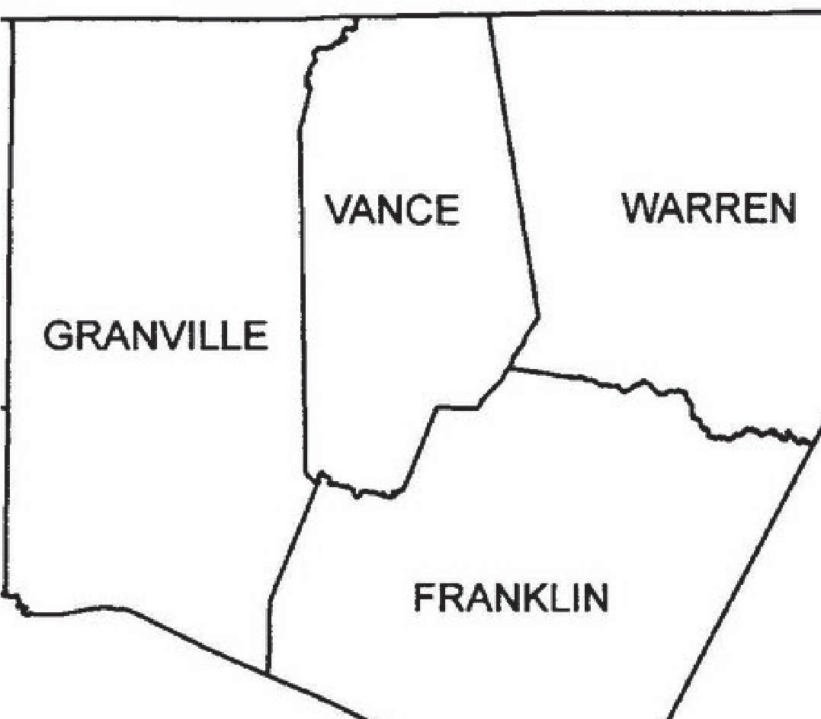

**934 (23.72%) (22.23.72%)**

**295 (7.49%) (7.7.49%)**

**1,141 (28.97%)**

**710 (18.03%)**

Other NC Counties - 230 (5.84%)

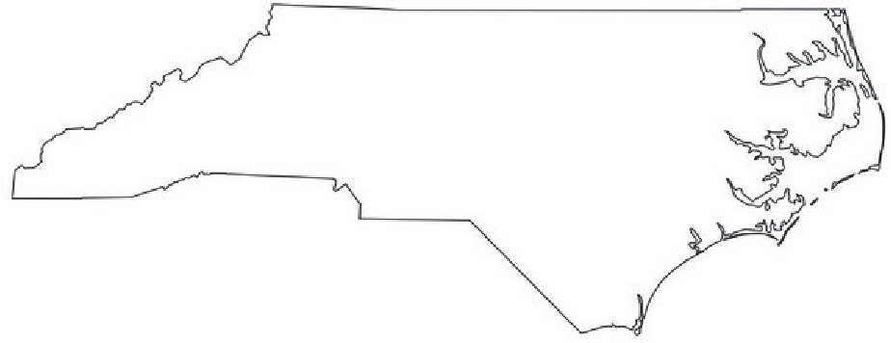

Non-NC Resident - 21 (0.53%)

Curriculum Graduates

Curriculum Graduates

(7/1/2023 thru 6/30/2024) as of 06/06/2024

|  |  |
| --- | --- |
| Total Completions | 768 |
| Total Associate Degrees | 472 |
| Total Diplomas | 70 |
| Certificates | 226 |
| Total Unduplicated Students Completing | 646 |

Data Obtained from Colleague on 9-16-24



Completer Demographics

|  |  |
| --- | --- |
| **Gender** | **% of Completers by Gender** |
| Female | 56% |
| Male | 44% |

|  |  |
| --- | --- |
| **Pell Recipient** | **% of Pell Eligible Completers** |
| No | 59% |
| Yes | 41% |

|  |  |
| --- | --- |
| **Female** | **% of Total Women Completers That Are…..** |
| American Indian/Alaska NA | 1.17% |
| Asian | 0.47% |
| Black/African American | 38.00% |
| Foreign | 0.47% |
| Hispanic | 8.39% |
| Multiple | 2.10% |
| Unknown | 3.50% |
| White | 41.72% |

|  |  |
| --- | --- |
| **Male** | **% of Total Men Completers That Are…..** |
| American Indian/Alaska NA | 0.29% |
| Asian | 2.06% |
| Black/African American | 13.57% |
| Foreign | 0.29% |
| Hispanic | 13.27% |
| Multiple | 1.18% |
| Unknown | 6.49% |
| White | 56.93% |